T5 Random errors

Purpose

The aim of the exercise is to learn the basic concepts of statistics used in the calculation of type A uncertainties for direct measurements. Type A uncertainties are determined when in the series of individual measurements of the same quantity there is a scatter of readings caused by random errors. The exercise presents a procedure for a large series of individual readings, i.e. a cardinality greater than 30. For a smaller series of calculations, the uncertainties are slightly different.

**1. BASICS**

**Random event** - the concept is not strictly defined; it is used to describe random phenomena, i.e. in which the occurrence of a particular event lies wholly or partially beyond the reach of human control. The event has the property of random occurrence or non-occurrence. Probability and mathematical statistics, examining mathematical models of random phenomena, assigns a probability to a random event, ie a number expressing the possibility of its occurrence.

**Population** - these are all elements (random events) of the set; eg a set of resistance values of a series of resistors with the same nominal values (it is a finite population), or a set of network voltage values (in theory it is an infinite population).

**Sample** - elements of the population selected for research; the sample's size depends on its representativeness for the whole population.

*Fig.1. Population and sample*

**Random variable** - if each of the random events of the population or sample is assigned to a certain real number, then the set of these numbers is the real function called the random variable. A random variable can be a continuous or discrete function.

**Distribution of random variable** - shows the correlation between the values of a random variable and the probabilities of their occurrence.

In nature and technology of particular importance is the **normal distribution**. Used to describe such random phenomena in which there is a large number of random events, which affects negligible lot of independent factors. Such conditions also occur in measurements. Namely, when measuring the same quantity in unchanging conditions, the random spread of results will occur when the readings are repeated many times, then the assessment of the uncertainty of these measurements may be based on a normal distribution.

**Histogram** - bar graph illustrating the frequency of occurrence of the value of a random variable in the examined sample. Based on empirically obtained histogram it is requested distribution of the random variable sample.

**Mean value** of n measurements of the same quantity, made with the same care and the same measuring instrument (or measuring system), while meeting the condition of negligible systematic errors, determines the most true (reliable) value of the measured quantity:

, where Xi is the result of a single measurement.

**Deviation of a single measurement result from the mean** 

**Standard deviation of a single measurement** 

**Standard deviation of the mean** =

2. UNCERTAINTY TYPE A - STANDARD AND EXPANDED

In the measurements, the standard deviation was assumed to be called standard uncertainty of measurement. Standard uncertainty is marked with the u(x) symbol, that is for the mean value: .

Standard uncertainty  it is a range of values centred around the mean value and determines the range in which the real measured value is probably located. And the standard uncertainty of a single measurement u(X) determines the range in which the next measurement result is likely to be.

The term "probably" means that the width of the range around the average value depends on the desired confidence in the final measurement result. The higher the probability is, the wider the range will be. For the assumed probability, the width of the division determines the expanded uncertainty, calculated from the formula:

,

where k *–* is the expansion factor, so-called the level of confidence, depending on the type of distribution and the assumed probability.

If the probability density distribution of the measurement results is a normal distribution, also with the Gaussian distribution (Fig.2), then *k* takes the values from the following table:

|  |  |  |  |
| --- | --- | --- | --- |
| Confidence level - *p* | *k* | Mark on Fig.2 | uncertainty |
| 0,68 | 1 | 1 | standard - u(*x*) |
| 0,95 | 2 | 2 | expanded - U(*x*) |
| 0, 997 | 3 | 3 | expanded - U(*x*) |



Fig. 2. Normal distribution

( - basis symbol for standard deviation)

Relative uncertainty are calculated from formula:

- standard relative uncertainty 

- expanded relative uncertainty 

###### EXERCISE PROGRAM

1. Perform a series of measurements of the quantity indicated by the lecturer. From the results of the series of readings, calculate:

a) the mean value,

b) standard deviation,

c) the standard deviation of the mean.

d) the permissible total error of the instrument,

e) total standard uncertainty,

f) total expanded uncertainty,

g) correctly write the measurement result.

Tab.2.Measurement results and calculations for reading series ....................................

|  |  |  |  |
| --- | --- | --- | --- |
| i | Xi |  |  |
| **1** |  |  |  |
| **....** |  |  |  |
| **38** |  |  |  |
|  | |  |  |
| Mean value | |  | |
| Standard deviation | |  | |
| Standard deviation of the mean | |  | |

1. Make a graph Xi = f(i). Write a line of values: , 

and  and  and  on the graph.

1. Prepare histogram. To do this, divide the range of measured values into an odd number of equal sub-intervals (5, 7 or 9), and then specify the number of values occurring in the individual sub-ranges. The graph should show the mean value  and  and . Evaluate the obtained histogram in terms of its similarity to the normal distribution; check also whether the mean value belongs to the range with the highest frequency of occurrence of the measurement.

**DESCRIPTION OF EXERCISE EXECUTION**

Tab.2 Measurement results of voltage, date 3.02.2002, time 15:10-15:15

|  |  |  |  |
| --- | --- | --- | --- |
| date | 3.02.2003 |  | time15:10-15:15 |
| Instrument type | HP 34401A | Serial number | US36017958 |
| Voltmeter accuracy | 0,06%Ux+0,04%Un | | Un =750V |
| Measurement No | Measured value | Voltmeter error | Standard deviation of a single measurement |
| i | Ui | gU |  |
|  | V | V | V |
| 1 | 221,05 | 0,43 | 0,16 |
| 2 | 220,90 | 0,43 | 0,01 |
| 3 | 221,32 | 0,43 | 0,43 |
| 4 | 220,80 | 0,43 | -0,09 |
| 5 | 220,56 | 0,43 | -0,33 |
| 6 | 220,62 | 0,43 | -0,27 |
| 7 | 221,44 | 0,43 | 0,55 |
| 8 | 221,00 | 0,43 | 0,11 |
| 9 | 221,27 | 0,43 | 0,38 |
| 10 | 221,37 | 0,43 | 0,48 |
| 11 | 220,87 | 0,43 | -0,02 |
| 12 | 220,81 | 0,43 | -0,08 |
| 13 | 220,43 | 0,43 | -0,46 |
| 14 | 221,21 | 0,43 | 0,32 |
| 15 | 220,96 | 0,43 | 0,07 |
| 16 | 220,16 | 0,43 | -0,73 |
| 17 | 221,07 | 0,43 | 0,18 |
| 18 | 221,33 | 0,43 | 0,44 |
| 19 | 221,39 | 0,43 | 0,50 |
| 20 | 220,55 | 0,43 | -0,34 |
| 21 | 220,80 | 0,43 | -0,09 |
| 22 | 220,90 | 0,43 | 0,01 |
| 23 | 220,48 | 0,43 | -0,41 |
| 24 | 220,68 | 0,43 | -0,21 |
| 25 | 220,63 | 0,43 | -0,26 |
| 26 | 220,43 | 0,43 | -0,46 |
| 27 | 221,18 | 0,43 | 0,29 |
| 28 | 220,83 | 0,43 | -0,06 |
| 29 | 220,48 | 0,43 | -0,41 |
| 30 | 221,13 | 0,43 | 0,24 |
| Mean value | =220,89V |  |  |
| Standard deviation | | | s(U) = 0,3343V |
| Standard deviation of the mean | | | =0,0621V |

Mean value: 

Standard deviation: 

Standard deviation of the mean: 

Total uncertainty calculation (type AB) of direct measurements

The measurement result has three components. These are: the value of the measured quantity, measurement uncertainty and the level of confidence.

In the measurements under consideration, the total standard uncertainty is determined, which consists of:

- standard uncertainty of type A,

- standard uncertainty of type B.

Generally, manufacturers give accuracies of the instruments by means of the maximum error. Then, it is assumed that the probability distribution function of the instrument error is uniform and the component uncertainty type B is calculated from formula

, where gX is maximum (total) instrument error.

It was used **voltmeter HP 34401A**, where total error is given : (0,06%Ux+0,04%Un), so 

Standard uncertainty: 

**Combined standard uncertainty** is calculated on the base of uncertanty propagation law. According to it, the combined uncertainty is the element of the sum of the squares of uncertainty of type A and type B:



#### Measurement result with confidence level p=0,68: U±U(U)=(220,890,26)V

#### Measurement result with confidence level p=0,95 (k=2): U±U(U)=(220,890,51)V

**Histogram:** The result of a single voltage measurement *Ui* is the implementation of a random variable. The set of measurement results creates a sample. After all measurements are taken, the random variable *Ui* should be determined in ascending order. The range of variation of the random variable *U* is then revealed. In the present example, it is a <220,16V, 221,44V>. For the histogram of the frequency of the occurrence of measurement results, this range should be divided into an odd number of ranges (sub-ranges) of equal width:  The central interval should be closed on both sides.

|  |  |  |  |
| --- | --- | --- | --- |
|  | A | **B** | **C** |
|  | **INTERVAL** | **PREVALENCE** | **PROBABILITY** |
| Interval No | ...,↑*Ui*min+1, *Ui*min+2),... | the prevalence of Ui in the sample, for the sorted intervals | Probability of Ui in each interval |
| 1 | <220,16, 220,30) | 1 | 1/30 |
| 2 | <220,30, 220,44) | 2 | 2/30 |
| 3 | <220,44, 220,59) | 4 | 4/30 |
| 4 | <220,59, 220,73) | 3 | 3/30 |
| 5 | <220,73, 220,87> | 5 | 5/30 |
| 6 | (220,87, 221,01> | 4 | 4/30 |
| 7 | (221,01, 221,16> | 3 | 3/30 |
| 8 | (221,16, 221,30> | 3 | 3/30 |
| 9 | (221,30, 221,44> | 5 | 5/30 |
|  | sum | 30 | 1 |

The divided range of occurrence of the measurement results can be found in the column A of the table. The frequency of occurrence of *Ui* measurement results in individual intervals is then counted (column B). The histogram creation procedure is as follows: the X axis is assigned the sub-ranges for the occurrence of *Ui*values (data from column A), and the Y axis - the frequency of occurrence of measurement results in individual sub-ranges (column B).

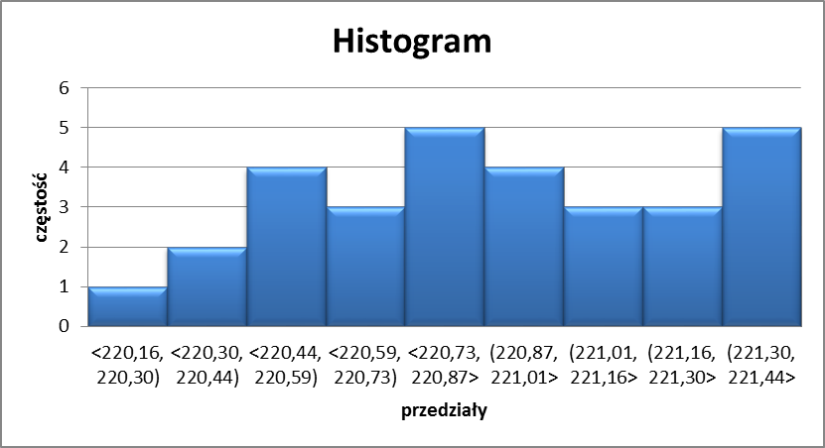

Fig. .3. Histogram